**NEWS APPLICATIONS**

**This Application is Developed by react native. The notes are used by learning the react native from scratch.**

1. **The first step is creating a react native project using expo frame work.**
2. **The next step is designing the Home for our application.**
3. **Menu bar creating.**
4. **Next fetch the news Api for our application.**
5. **Connect the Api data for our application.**
6. **The Sample Image is given below…**

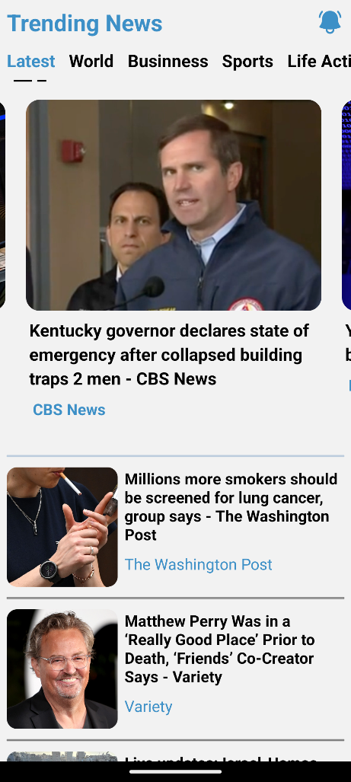

**This page is the home page of the application. The data fetching method is given below.**

**This is the Api fetching method…**

**First import the “**[**apisauce**](https://www.npmjs.com/package/apisauce)**” file in google. Next use the file in our application. The uses method is given below.**

**Programming Part…**

**---------------------------------------------------------------------------------------**

import { create } from "apisauce";

const api = create({

  baseURL: "Implement your own Api URL",

});

const Api = "Enter your Api key";

const TopHeadlines = api.get("Enter your headline" + Api);

export default {

  TopHeadlines,

};

**-> This is used for get the Api from the application.**

**This is one of the ways is fetch the Api data.**

**The next step is fetching the home page of the application. This method is used by the home screen.**

**If you fetch the application first create an async function in your program and next define the one variable to fetch the data. The fetching the data is stored the one of state value. Finally, the state value fetch Api of the application. The sample program is given below.**

 const [newsList, setNewsList] = useState([]);

  useEffect(() => {

    getTopHeadline();

  }, []);

  const getTopHeadline = async () => {

    const result = (await Api.TopHeadlines).data;

    setNewsList(result.articles);

  };

**The next step is implementing the data of the application. The next screen is a news screen. The screen is exploring the full news of the application. The sample image is given below.**

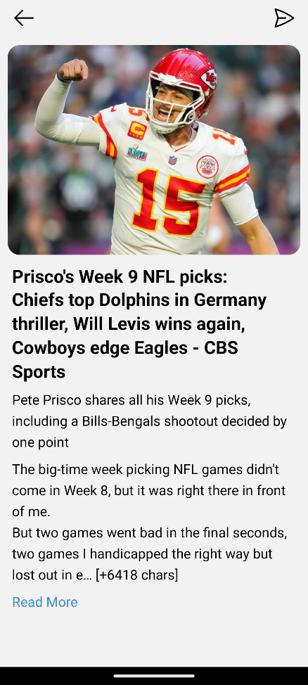

**The implementing code of data is given below…**

<View style={{ marginRight: 20 }}>

          <Text className="text-2xl font-bold mx-4 mt-3">{data.title}</Text>

        </View>

        <View>

          <Text className="text-lg mx-4 mt-2">{data.description}</Text>

          <Text className="text-lg mx-4 mt-2">{data.content}</Text>

        </View>

        <Pressable onPress={() => navigation.goBack()}>

          <Text style={{ color: "#3d90c7" }} className="text-lg mx-4 mt-2">

            Read More

          </Text>

        </Pressable>

**The screen includes the share option. The share option is used by an expo frame work.**

**First import the** [**expo share**](https://www.npmjs.com/package/expo-sharing) **file. The next step is used the share file.**

import {Share} from "react-native";

const shareNews=()=>{

    Share.share({

        message:data.title

    })

<Pressable onPress={()=>shareNews()}>

   <PaperAirplaneIcon color={"black"} size={32} />

</Pressable>

**The share option image is given below…**

